Basic Training

FT NavVision©

Day 5

Version 1.1 ● January 10, 2014

Commissioning and résumé

**Last edited: 10 January 2014**

**Copyright © 2011 FT NavVision© . All rights reserved.**

**No part of this publication may be reproduced, transmitted, transcribed, stored in a retrieval system, or translated into any language, in any form or by any means, electronic, mechanical, photocopying, recording, or otherwise, without prior written permission FT NavVision© .**

**All copyright, confidential information, patents, design rights and all other intellectual property rights of whatsoever nature contained herein are and shall remain the sole and exclusive property of FT NavVision© . The information furnished herein is believed to be accurate and reliable.**

**However, no responsibility is assumed by FT NavVision© for its use, or for any infringements of patents or other rights of third parties resulting from its use.**

**The FT NavVision© name and FT NavVision© logo are trademarks or registered trademarks of FT NavVision©**

**All other trademarks are the property of their respective owners**

|  |  |
| --- | --- |
| Publication type: | Training |
| Publication number: | FTT1301005 |
| Title: | Basic training FT NavVision® day 5 |
| Subject: |  |
| Issue: | 1.1 |
| Publication date: | Februari 21, 2013 |
| Total number of pages: |  |
| Author: |  |

Inhoud

1. Commissioning 5

1.1 Introduction 5

1.2 Preconditions 5

1.3 Topology 6

2. Performance 6

2.1.1 Modules 6

2.1.2 Memory 8

2.1.3 Network 9

2.1.4 IP Owner List (which OWS is handling which ip’s) 10

2.1.5 IP 11

2.1.6 Serial 12

3. Keeping up to date 16

3.1 Introduction 16

3.2 Direct changing 16

3.2.1 insert 17

3.3 Bigger changes 17

3.4 Keep the sensorlist up to date afterwards 20

3.4.1 Introduction 20

3.4.2 What do you need 20

3.4.3 Cleaning up after a day on board 21

3.4.3.1 Copy devicelist.dat and sensorlist.dat 21

3.4.3.2 The old sensorlist 21

3.4.3.3 Startup your project folder 22

3.4.3.4 Inspecting the generated files 23

3.4.3.5 Comment 24

3.4.3.6 Changed 24

3.4.3.7 Failed 25

3.4.3.8 Missing 26

3.4.3.9 New 26

3.4.3.10 Keep importing 26

3.5 Commissioning steps 27

3.5.1 Wiring schematics 27

3.5.2 Wiring, cables and connections 27

3.5.3 System components 29

3.5.4 System start-up 29

3.5.5 FT NavVision® software 30

3.5.6 Firmware devices 30

3.5.7 LAN and serial connections 31

3.5.8 CAN bus connections 32

3.5.9 Wago 32

3.5.10 PLC program 33

3.5.11 Wago performance 33

3.5.12 Buttons 34

3.5.13 Alarms and viewers 34

3.5.14 Tank calibration 35

3.5.15 Servers and clients 35

3.5.16 Alarms 36

3.5.17 Network connection 36

3.5.18 Viewer and mimics 37

3.5.19 Cold start and completion of test 38

Figures

Figure 1‑1: System layout 6

Figure 2‑1: Performance 7

Figure 2‑2: Memory 8

Figure 2‑3: Network 9

Figure 2‑4: IP Owners List 10

Figure 2‑5: Performance > IP 11

Figure 2‑6: Serial 12

Figure 2‑7: Additional Serial Data 13

Figure 2‑8: Communication Diagnostics 1 14

Figure 2‑9: Communication Diagnostics 2 15

Figure 3‑1: changing baudrate old 16

Figure 3‑2: Changing baudrate new 16

Figure 3‑3: Changing Wago original 17

Figure 3‑4: Changing Wago lines 17

Figure 3‑5: Changing Wago numbers 17

Figure 3‑6: Inserting a Wago slice 1 18

Figure 3‑7: Inserting a Wago slice 2 18

Figure 3‑8: Inserting a Wago slice 3 19

Figure 3‑9: Excel trick 1 19

Figure 3‑10: Excel trick 2 20

Figure 3‑11: clean FT NavVision© folder 21

Figure 3‑12: Devicelist.dat and sensorlist.dat in network folder 22

Figure 3‑13: sensorlist.xls in root of project folder 22

Figure 3‑14: root folder after import sensorlist 23

Figure 3‑15: Comment example 1 24

Figure 3‑16: Comment example 2 24

Figure 3‑17: Comment example 3 24

Figure 3‑18: Changed example 1 25

Figure 3‑19: Changed example 2 25

Figure 3‑20: Changed example 3 25

Figure 3‑21: Failed example 1 25

Figure 3‑22: Missing example 1 26

Figure 3‑23: New example 1 26

Tables

Table 3‑1: Import Result fields 24

# Commissioning

## Introduction

The commissioning is the part where you go onboard of a ship to check whether everything is working and to make small adjustments. Also it is an excellent time to train the crew for working with the system.

You can imagine that it is quite important that you handle things in an orderly manor during commissioning. We already handled a lot of this in the right order during the training, but it will be wise to give you some guidance.

## Preconditions

* All FT NavVision® system components like computers, switches, PLC, interfaces, have to be mounted, connected and powered
* All components like sensors, engines, generators, I/O components must be connected to the corresponding sensors and interfaces of the FT NavVision® system
* The server computer(s) as well as client computer(s) must be up and running
* All network and serial cables, must be connected
* The remote service unit must be connected and installed with a working GPRS Sim-cart or VSAT-connection
* Engines, generators, radar and all other equipment within the FT NavVision® system must be ready for testing
* The alarm system(s) must be working and ready for testing
* During the time of commissioning and acceptance tests there need to be assistance from a technician who is familiar with the system installation.

## Topology

You will go to the ship with the latest schematics and maybe back-up file you have. First thing you always do is check out if the installation reconcile with the schematics you have. Is everything connected according the schematics than it is OK. If not, ask what happened and make sure that you change the schematics for future reference.

The next thing you will check if the network is connected properly and works as it is supposed to work. Make sure that you also check the physical connections because that is one of the points that it usually goes wrong. For reference you can use the network system layout in FT NavVision© to see if everything is connected (see Figure 1‑1).

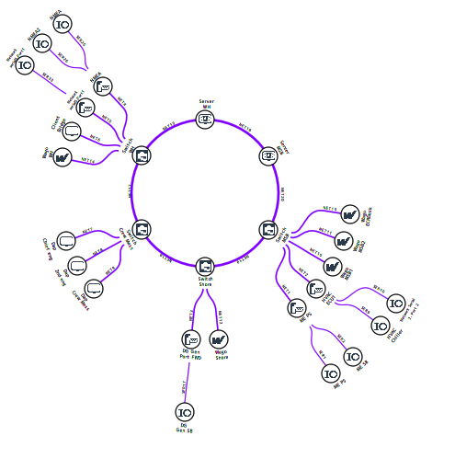

Figure 1‑1: System layout

*: Make sure that every connection and the topology is correct before you move on.*

# Performance

### Modules

Under “F11 > Modules” the time period is shown that each NavVision® module uses in relation to the total NavVision® time.

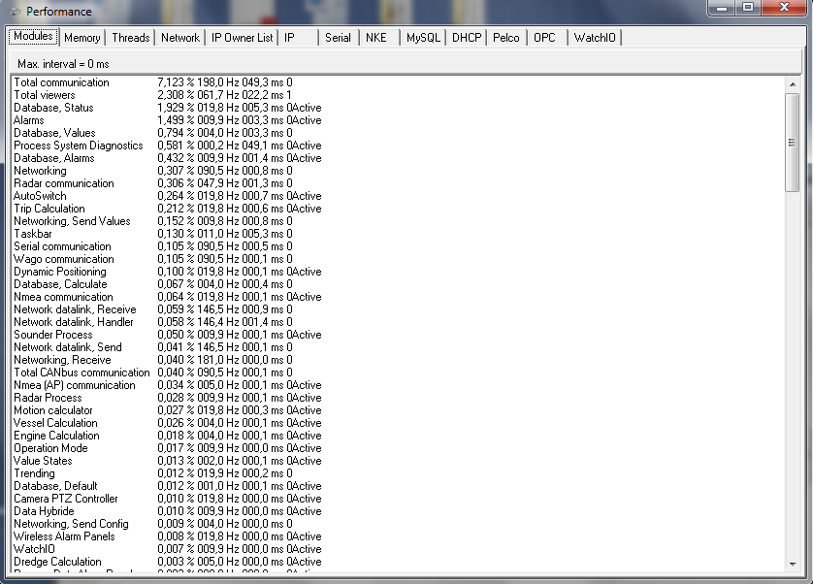

Figure 13‑1: Performance

The columns are arranged as follows:

|  |  |
| --- | --- |
| **Detail** | **Description** |
| Module Name | Internal name used by NavVision® to describe the module |
| Percentage | Percentage of processing time, where total NavVision® is 100% |
| Refresh Rate | Processing time in milliseconds |
| Total time | Total (module) processing time (in milliseconds) |
| Semaphore | Should be “0” or “1” |
| Active | Shows during refresh of screen |

### Memory

Under “F11 > Memory” developers can track for the presence of possible memory leaks.

By default the option “Activate memory manager” is disabled to avoid significant performance degradation.

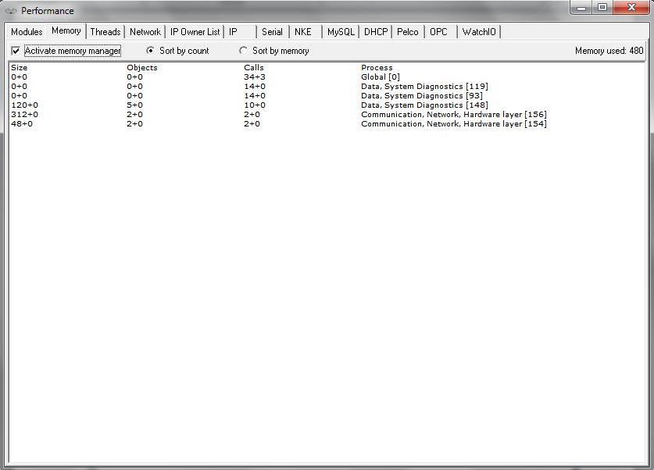

Figure 13‑2: Memory

The columns are arranged as follows:

|  |  |
| --- | --- |
| **Detail** | **Description** |
| Size | The size (bytes) of an object |
| Objects | Relative numberof objects created or deleted since activation of memory manager |
| Calls | Number of creation / deletion calls |
| Process | Process creating / deleting the objects |

 Take special notice of the “Memory Used” at the right top of the pane. If it keeps rising beyond your memory available, a memory leak is imminent.

### 

### Threads

Under “F11>Threads” all the threads that are currently running will be visible. This option is quite easy for troubleshooting certain threads.

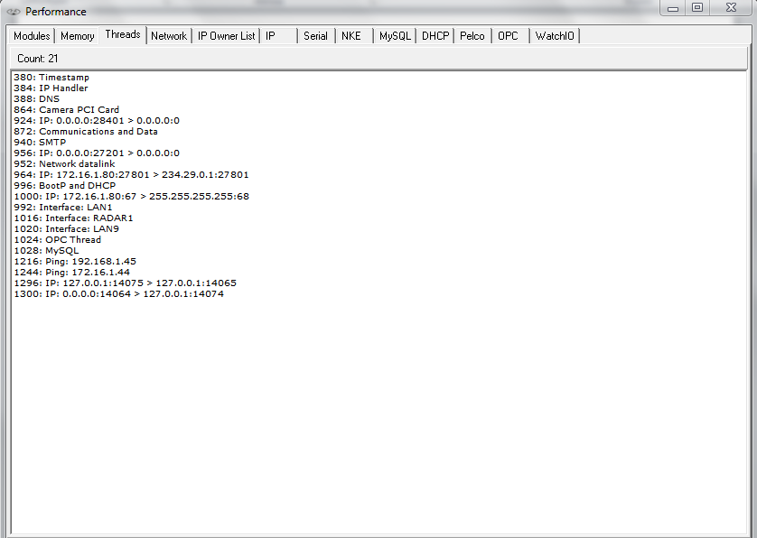

Figure 13‑3: Threads

### Network

Under “F11 > Network” the Connection to other workstations within the same system is shown. With all workstations connected and running, you will see your complete topology visible here.

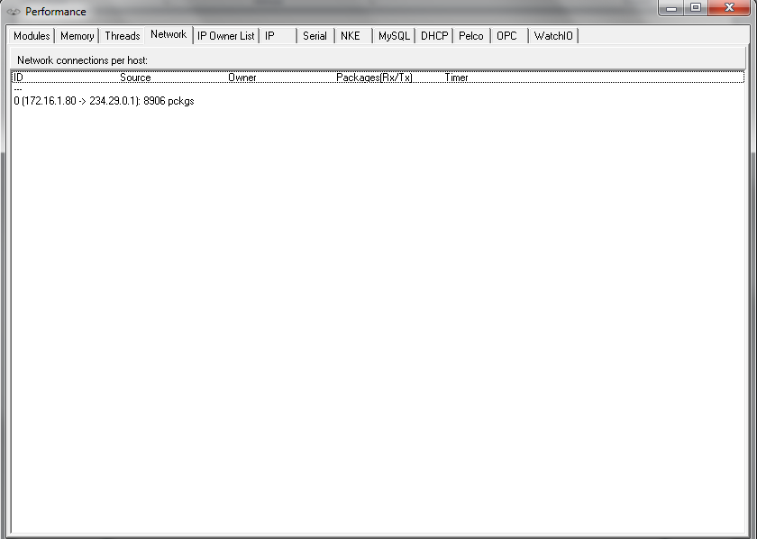

Figure 13‑4: Network

The columns are arranged as follows:

|  |  |
| --- | --- |
| **Detail** | **Description** |
| ID | Internal index used by NavVision®, not of importance in this list |
| Source | Active > when connected  Connect > when trying to connect  Closing > when closing the connection |
| Owner | UDP server, UDP client, TCP server or TCP client |
| Packages | The source of the connection. When “0.0.0.0:0” is shown, no source address was specified when opening the connection, where “0.0.0.0:x” means that port “x” on this computer is being used for server functionality |
| Timer | The destination of the connection |

### IP Owner List (which OWS is handling which ip’s)

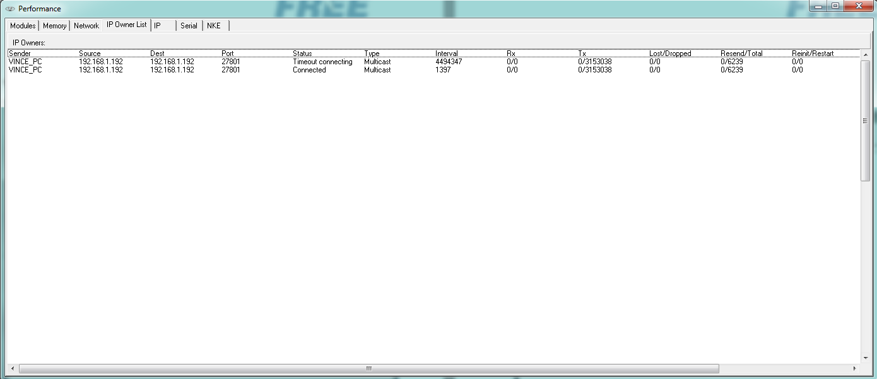

Figure 13‑5: IP Owners List

The columns are arranged as follows:

|  |  |
| --- | --- |
| **Detail** | **Description** |
| Sender | The workstation you are working on |
| Source | The workstation the connection is made from |
| Dest. | The interface that the source is (trying) to reach |
| Port | The port that is used for the connection |
| Status | The status of the connection |
| Type | Type of connection: Multicast, TCP, UDP |
| Interval | The interval between the last attempt |
| Rx | Receiving side |
| Tx | Transmitting side |
| Lost/Dropped | Packages lost/dropped |
| Resend/Total | Packages asked to be resend/total |
| Reinit/Restart | Reinitialisation/restart of the connection |

### IP

Under “F11 > IP” a list of all network connections as handled by the relevant NavVision® workstation is shown

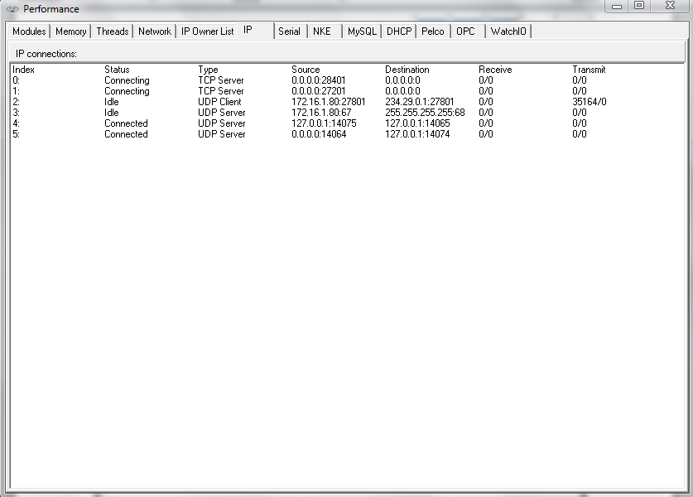

Figure 13‑6: Performance > IP

The columns are arranged as follows:

|  |  |
| --- | --- |
| **Detail** | **Description** |
| Index | Internal index used by NavVision®, not of importance in this list |
| Status | Active > when connected Connect > when trying to connect  Closing > when closing the connection  Idle > When doing nothing |
| Type | UDP server, UDP client, TCP server or TCP client |
| Source | The source of the connection. When “0.0.0.0:0” is shown, no source address was specified when opening the connection, where “0.0.0.0:x” means that port “x” on this computer is being used for server functionality |
| Destination | The destination of the connection |
| Receive | Number of Bytes left in the internal buffer / Number of bytes received |
| Transmit | Number of Bytes left in the internal buffer / Number of bytes sent |

### Serial

Under “F11 > Serial” the serial port status is indicated.

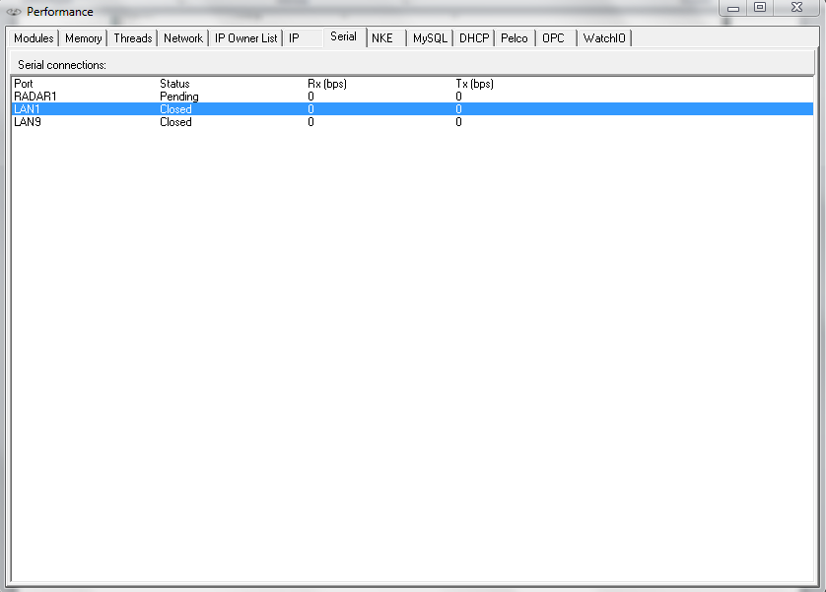

Figure 13‑7: Serial

The columns are arranged as follows:

|  |  |
| --- | --- |
| **Detail** | **Description** |
| Port | The serial port name. The possible radar port is also shown as a serial port, named “RADAR1”. When it is not used, the status stays on “Pending”. |
| Status | Serial port status i.e. “Failed”, “Pending”, “Closed” and “Open” |
| Rx (bps) | Number of bits “Received (Rx)” during the last second |
| Tx (bps) | Number of bits “Sent (Tx)” during the last second. |

For troubleshooting you can right-click on a serial port to see a pop-up you can click for additional data (See Figure 13‑8)

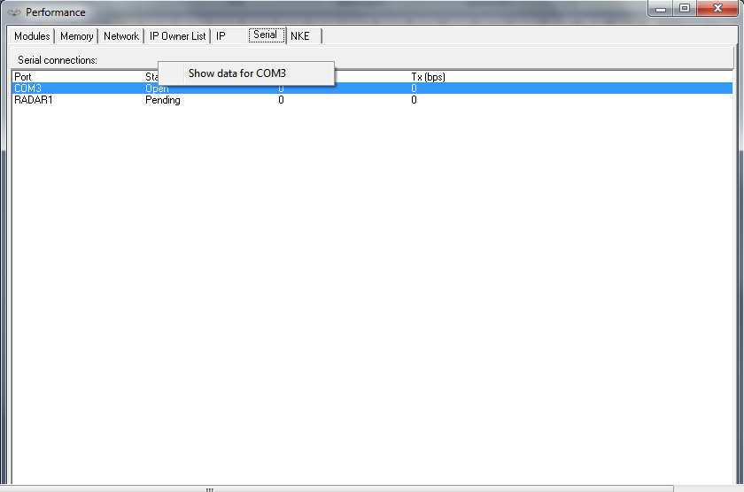

Figure 13‑8: Additional Serial Data

After clicking “show data for x” where x is the appropriate port, you will get a new pop-up field Communication Diagnostics. (see Figure 13‑10 and Figure 13‑10)

This tool you can use to troubleshoot data over serial ports. Here it shows all the data that is actually seen by NavVision® on the specific port.

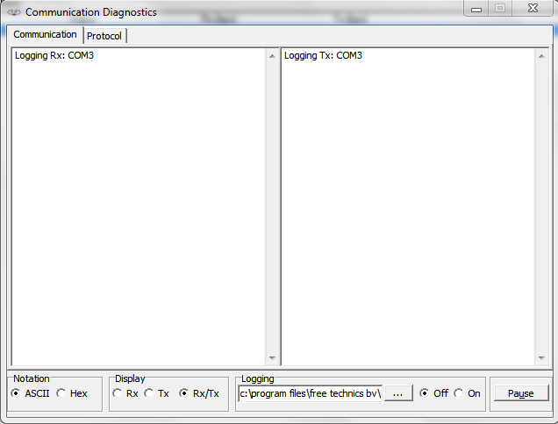

Figure 13‑9: Communication Diagnostics 1

|  |  |
| --- | --- |
| **Detail** | **Description** |
| Notation | Show data in ASCII or Hex |
| Display | Rx > Only show receiving side Tx> Only show transmitting side  Rx/Tx > Show receiving and transmitting side |
| Logging | Choose destination to save logfile and switch it off or on |
| Pause | Pause the data stream |

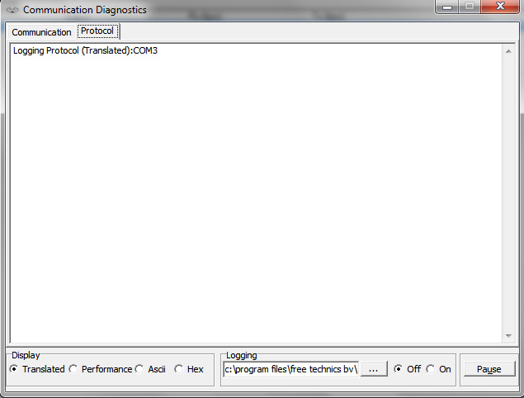

Figure 13‑10: Communication Diagnostics 2

|  |  |
| --- | --- |
| **Detail** | **Description** |
| Protocol | Shows the different protocols |
| Display | Translated > shows the data in readable output Performance > Shows the performance of the data  ASCII > Shows Data in ASCII  Hex > Shows Data in Hex |
| Logging | Choose destination to save logfile and switch it off or on |
| Pause | Pause the data stream |

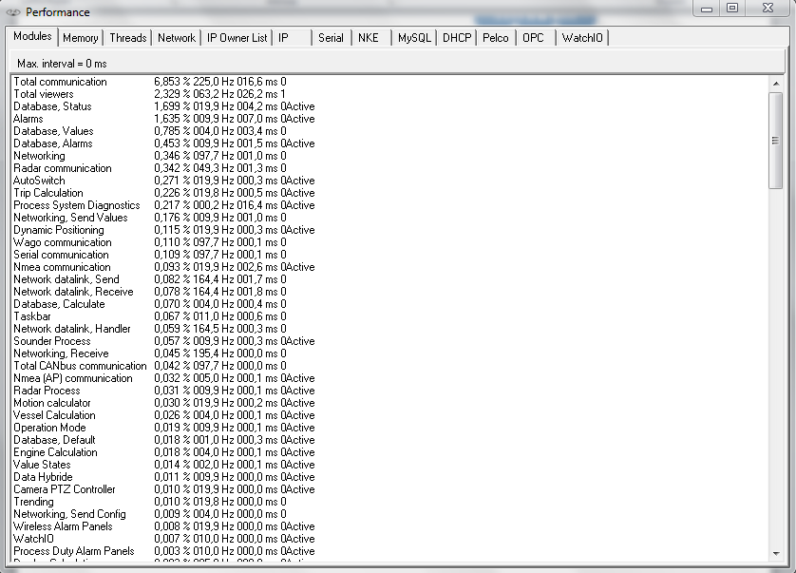

Figure 13‑11: Latest version

In the latest version there are a few new items added. These are however beyond the scope of this manual. Please feel free to explore them

After this we are going to make sure that the sensorlist is up to date as we have done earlier in this training.

# Keeping up to date

## Introduction

Now you have seen what the sensorlist is capable of, you might have guessed that the sensorlist is the spill of the system. From the first build, up to changing large amount of data, the sensorlist is the tool for working with FT NavVision©.

It is very important that you keep the sensorlist up to date during commissioning. The best way to do this is probably have the sensorlist open at your laptop and change immediately everything that you change in FT NavVision© on board. We know that it is sometimes very hectic and you don’t have the time to do this directly. In that case it’s best that you change it right after you finished your days’ work. This way you can use the sensorlist the next day again.

We will explain here the different methods of keeping the sensorlist up to date.

## Direct changing

So this is the one that you keep the latest sensorlist open at your laptop, next to the workstation that you are working on. When you alter something directly on the workstation, you can immediately change that in the sensorlist.

Let’s say that you are working on the workstation and you find out that the serialnetwork on moxa 1 port 1 has a different baudrate. The seriallan is the 1st one in the ER en you have to change port 1 to a baudrate of 38400 instead of 115200. In FT NavVision© you change this on the workstation and the connection seems to be good.

Next time you import the sensorlist, you might wonder why the port isn’t working anymore. This is why you need to change it in the sensorlist in the tab “devicelist” to make sure next time the import will be in order. So go to your laptop, click on the devicelist tab and change the baudrate accordingly (see Figure 3‑1 and Figure 3‑2).



Figure 3‑1: changing baudrate old



Figure 3‑2: Changing baudrate new

Same goes for the changes in the sensorlist. Again you’re working on the workstation and you notice that you have to change a connection at the Wago. It seems that the connections on the Wago Workshop are switched. The sensor on pin 3 is on pin 5 and the sensor on pin 5 is on pin 3. Of course you can change the wires on the Wago itself but for argument sake we say that you change the fieldnames in the Wago-section of the workstation.

Again you need to change this in the sensorlist or it will get back to the old state as you import the sensorlist again. The original lines you will find in the next figure:



Figure 3‑3: Changing Wago original

Now you can switch the whole line with names, fields and everything (see Figure 3‑4). Realize that you still need to change the pin-number, or nothing will change. For readability this will be the best option and also if you have to change a lot of pin numbers this is more synoptic. There will be an example later.



Figure 3‑4: Changing Wago lines

If it is about small amounts of changes it is easier to just change the pin-number. FT NavVision© doesn’t mind and will put it in the right order into the system. See next figure:



Figure 3‑5: Changing Wago numbers

### insert

When you need to insert a new connection into the Wago (an extra sensor for example), it could be very easy to do as you can read in the “Installation and commissioning manual”. Just choose a free pin in FT NavVision© Tools>Configuration>Wago. However, don’t forget to put that also in the sensorlist or you will lose that connection again after importing.

Same goes for extra devices in the “devicelist” tab. Just remember: importing a sensorlist will overwrite every change you have made on the system.

## Bigger changes

One of the bigger changes that can take place is that you have to change the order of the Wago slices or you will have to add a Wago slice somewhere. This will mess up the whole configuration. Without using the sensorlist this is almost impossible to do.

Let’s pretend you have the following configuration:

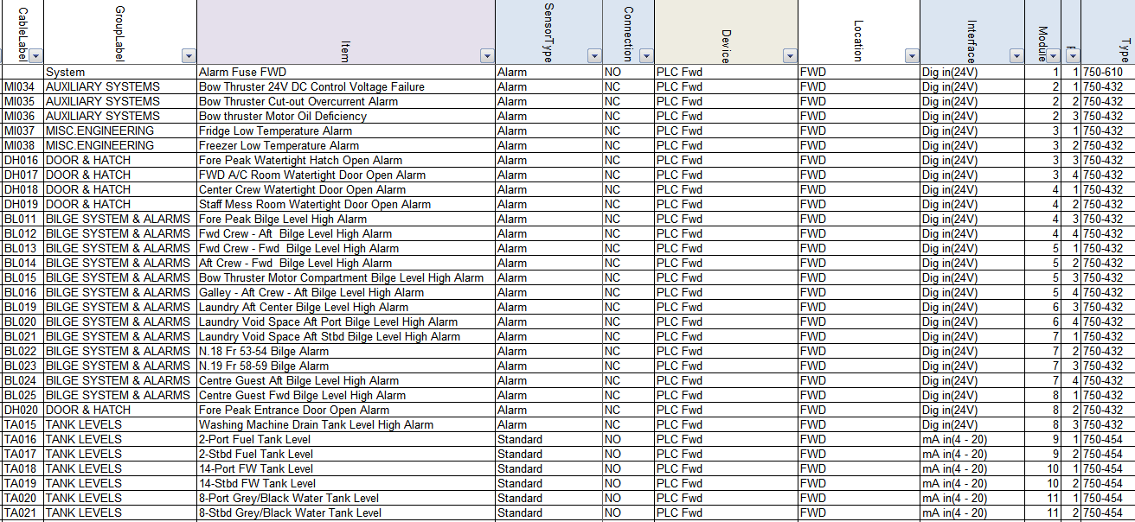

Figure 3‑6: Inserting a Wago slice 1

Now you need to put an extra slice (DI) 750-432 after the 3rd slice in the Wago. If you do that FT NavVision© will see that as a slice without a number and all the fields after slice 3 will go back one slice. You can imagine that is not what we want.

Now let’s do this with the sensorlist. You insert an empty row after the 3rd slice (see Figure 3‑7). Now this will be the 4th slice so at the module column you say it is number 4 and you fill in all the other appropriate fields (see Figure 3‑8).

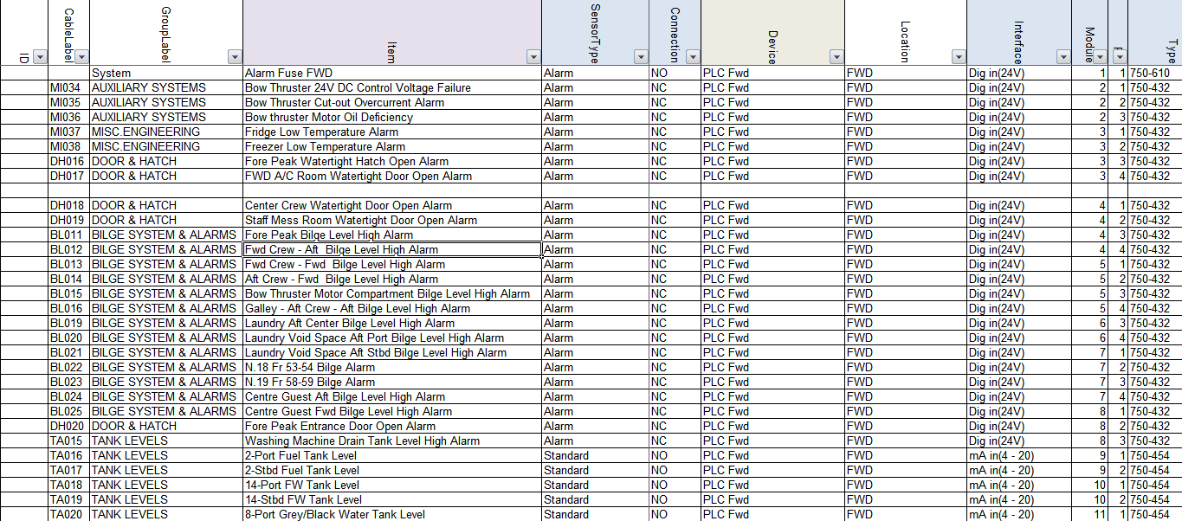

Figure 3‑7: Inserting a Wago slice 2

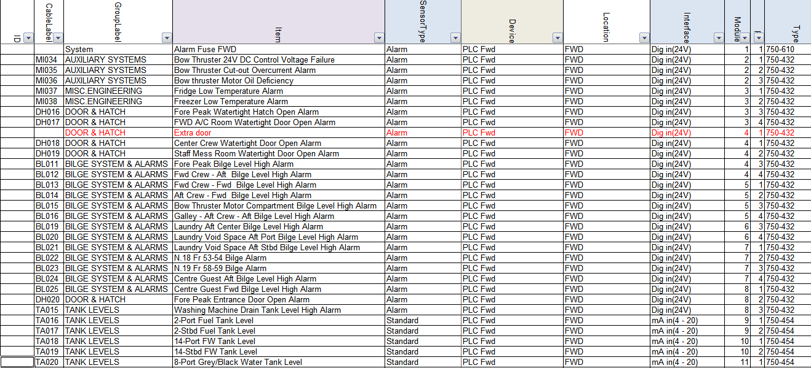

Figure 3‑8: Inserting a Wago slice 3

Now you will have two Wago slices with number 4 so you will need to increase the rest of the module numbers on that Wago. Of course you can do this by hand, but Excel is very helpful in this. Just find a cell with number 1 in it (cause we need to increase the modules by 1) an click CTRL-C to copy the number. Now select all the select all the cells in the module-column that need to be adjusted and right-click. Select “Paste Special” (see Figure 3‑9).

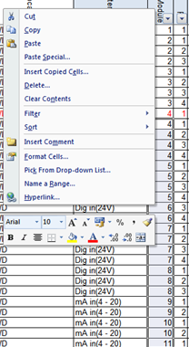

Figure 3‑9: Excel trick 1

In the next window choose “Add” and then click OK (see Figure 3‑10). You will see that all the module numbers has increased by 1.

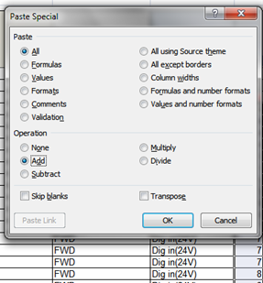

Figure 3‑10: Excel trick 2

Now you can easily import the sensorlist (after you inserted the new Wago slice) and it will set everything in its right place.

## Keep the sensorlist up to date afterwards

### Introduction

Most likely you will find yourself occupied with work or you will get on board and the crew has made a lot of changes. In both cases it is impossible to use the sensorlist because it probably makes more problems than that it serves you. In that case you need to clean up the sensorlist first. After the clean-up you can use the sensorlist again.

To clean up the sensorlist you need to follow the instructions below. This is, for now, the best way to do this. The bigger the sensorlist is and the more changes, the more time-consuming it will be. But in the end you will only benefit.

### What do you need

You need a complete clean installation of the latest FT NavVision© on your pc/laptop. Keep this one clean and copy your key file (the *.key.ini) into the folder NavVision/config/network.

If you start at a new project, or wish to make a new beginning, make a new folder and name it after your project. Copy al the files from the clean FT NavVision© folder into your new folder. You will get the following folder:

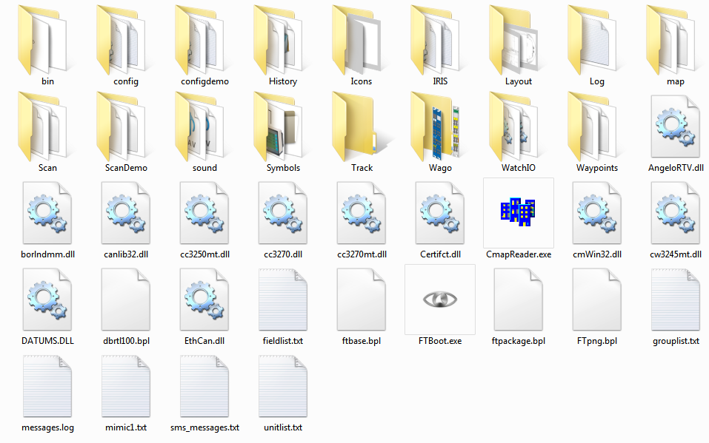

Figure 3‑11: clean FT NavVision© folder

Also you need the config-folder from the installation on board (better back-up the whole FT NavVision© folder). You can do this at the end of the day, when you have finished working on the system, or at a ship that you arrive at for commissioning.

### Cleaning up after a day on board

After you have been on board all day we assume that you have made a backup of the system. Now you do have an existing sensorlist, but we need to find out the changes. Here are the steps you need to take.

#### Copy devicelist.dat and sensorlist.dat

In the backup you took with you from aboard you find two files in the folder NavVision/config/network. These files are:

* Devicelist.dat
* Sensorlist.dat

Now copy these files and paste then in the folder NavVision/config/network of the folder you made on your pc/laptop as in Figure 3‑11. This folder now contains the configuration on board as it was when you left. Don’t start up yet.

#### The old sensorlist

You also have the old sensorlist.xls that you had before you went on board. If you do not already have the file as described, but only the raw sensorlist, we refer you to Chapter **Fout! Verwijzingsbron niet gevonden.** to see how to save a sensorlist for import.

Copy this sensorlist.xls in to the root of your project folder. It will now look as follows:

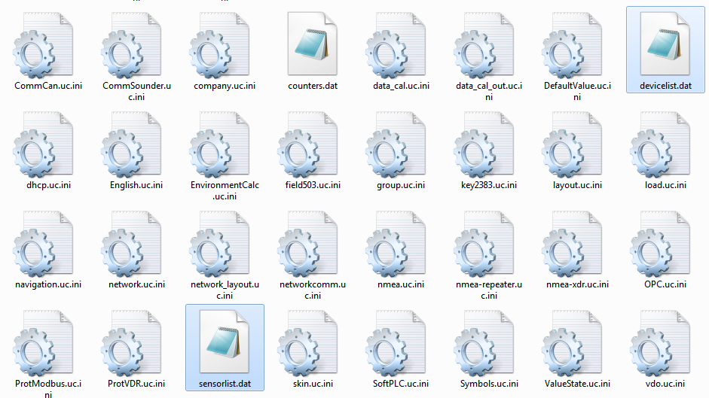

Figure 3‑12: Devicelist.dat and sensorlist.dat in network folder

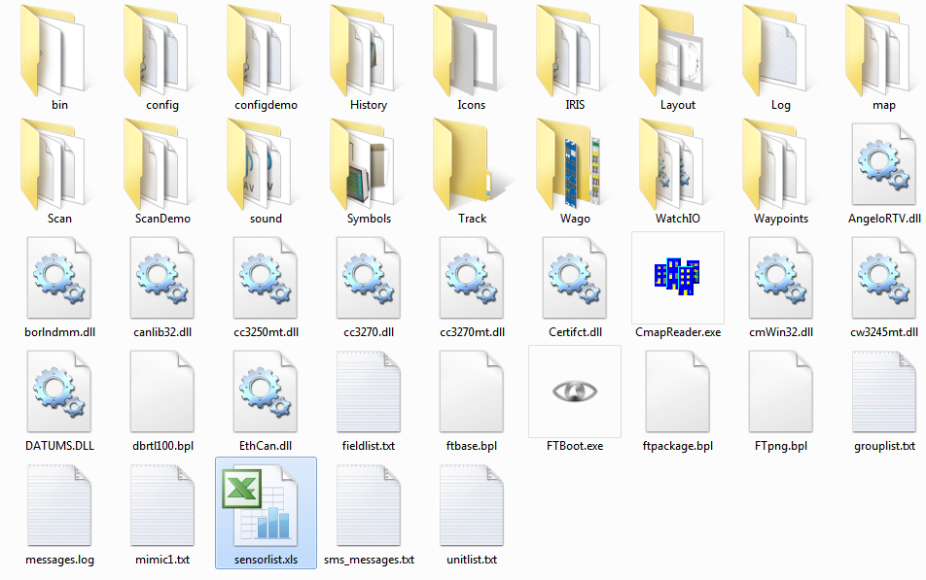

Figure 3‑13: sensorlist.xls in root of project folder

#### Startup your project folder

Now you must start up the FT NavVision© that is in your project folder. To do so, go to the folder NavVision/bin and double-click the NavVision.exe. This way you know that you start the right version.

During startup FT NavVision© will ask you if you want to import the devicelist and after that the sensorlist. Answer both questions with “Yes”. FT NavVision© will start up completely.

After it started up you can shut it down immediately. FT NavVision© will now generate de devices you need. These are:

* devicelist_generated.html
* sensorlist_generated.html
* sensorlift_generated_diff.html

These files can be found in the root of your projectfolder which now looks like the following:

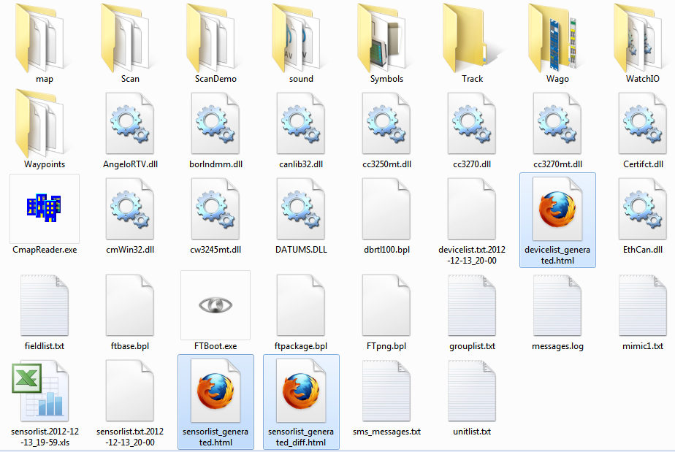

Figure 3‑14: root folder after import sensorlist

#### Inspecting the generated files

What goes for the sensorlist_generated will also count for the other generated files, so we will only discuss this file here.

Open up the sensorlist_generated.html (right-click, open with, Microsoft Office Excel). You will now have the sensorlist but also the column ImportResult filled in. If the field is blank than nothing has changed. Just pay attention to the fields that are colored and have a result in it.

This results can be:

|  |  |
| --- | --- |
| Field | Description |
| Comment | Comment that something is different in the field |
| Changed | Notice that something has changed |
| Failed | Critical failure somewhere in the field |
| Missing | Field tag is missing |
| New | Field is added since last import |

Table 3‑1: Import Result fields

This results will almost always be explained by the same color in the row that triggered the code.

Also you can open the sensorlist_generated_diff.html to see a reference to the same row (the old value that was there before you imported the sensorlist).

#### Comment

Comment usually indicates a minor problem or no problem at all, but you will need to check them. A simple example is that you see the following line:



Figure 3‑15: Comment example 1

If you look further down the row you will see that the problem is the text “bulb nav light SB 1” as you see in the next figure:



Figure 3‑16: Comment example 2

The fact is that “comment” usually indicates that the text is already in use somewhere in the sensorlist. Also it is possible that the field, in this case “AftNavLightSB” is already in use. Use the search function of Excel to find the text throughout the sensorlist.

In this case we will find that the text and the field is also used in line 71 as showed in the next figure:



Figure 3‑17: Comment example 3

You always have to check closely, but in this case it is fairly easy. Line 44 is the status connection as you will find in the SensorType column and it is connected to a DI-module. Line 71 is Standard connection and is connected to a DO-module. As you know how FT NavVision© works this is no problem. With line 71 you can switch the line on and if the light is on it will give a status back on line 44.

Now you now it is no problem and you can leave the row as is.

*: although it is only a comment, do check all fields for abnormalities. If you are sure it is ok, mark it in the sensorlist.*

#### Changed

Changed indicates that there is a bigger problem. It is a warning. It can be that a value has changed in the min/max settings, or an Item-name is changed or even the interface is changed. Eventually something can be changed in either column.

For your convenience FT NavVision© will show the changed cell in yellow as well. So it is easy to look up. It can even be in multiple cells, so have a good look. See the next figures as example:



Figure 3‑18: Changed example 1



Figure 3‑19: Changed example 2

As you can see there is a yellow colored field that will give you the changed value. In these examples it changed the interface. If you are not sure why it is changed or what was there before, you open up the sensorlist_generated_diff.html to see the reference. If we take the second figure as example and we look that up in the sensorlist_generated_diff.html, we’ll see the following:



Figure 3‑20: Changed example 3

Now you can check that in FT NavVision© it was defined as mV in(-125-125). As FT NavVision© knows that a Wago 750-469 slice is a Thermo in (K) slice it changed that interface to the right one.

Now that you know that it was changed because of the right reason, you also will have to change it in your sensorlist to keep that up to date.

*: make sure that you check all the changed fields and adjust them accordingly in your sensorlist. It is not possible with a changed field that you leave one unchanged. They all need to be altered in your basic sensorlist.*

#### Failed

Failed is a critical warning. There is something really wrong in that specific line. It can be anything, from missing information to double sensors. You will have to check the line very carefully. Sometimes it will show a red colored cell to show you what is wrong, but other times you will have to dig deeper to find the problem.

Failed always needs to be rectified in your original sensorlist. Here a simple example:



Figure 3‑21: Failed example 1

This is a sensor on a bus-protocol. As you can tell it was put twice in the sensorlist. Bus-protocols can hang on such information, so it is wise, in this case that you remove the Failed line from your original sensorlist.

#### Missing

Missing is an easy one. In this row the field tag is missing. You can go straight to the Field-column and you will find it is empty. See next figure:



Figure 3‑22: Missing example 1

Find the right field as described in Chapter **Fout! Verwijzingsbron niet gevonden.** and put that in the original sensorlist.

#### New

Everything that was changed on board and that wasn’t already in the sensorlist will become visible as new. This could be a new sensor on a Wago, but also a complete new device or interface with, for example a bus-protocol.

The next example is when a new device or interface is connected. You will see the following:

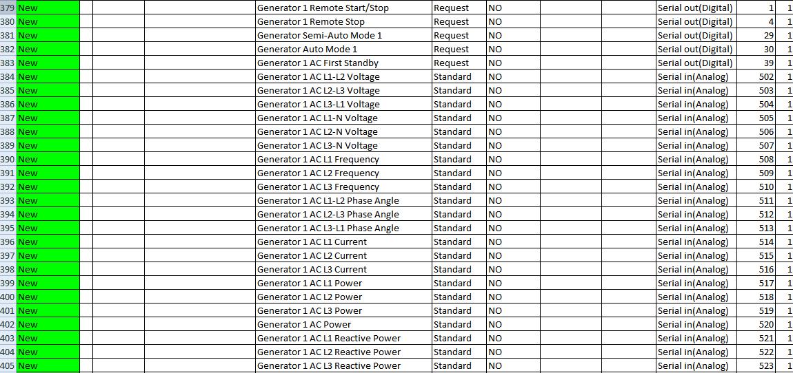

Figure 3‑23: New example 1

You can understand that you have to copy all these lines and paste them into the original sensorlist or they will get lost with a new import.

#### Keep importing

After you checked and replaced all the import results into the original sensorlist, you once again convert it to a sensorlist for import as described in Chapter **Fout! Verwijzingsbron niet gevonden.** and put it in the root folder of your project folder.

Start FT NavVision© again and import the devicelist and sensorlist. Close FT NavVision© and open the new sensorlist_generated.html.

If you did well there are no more import results except maybe for a few comments that you left there. If not you will have to repeat this process over and over again until there are no more import results and the sensorlist_generated_diff.html is empty.

Once you have reached that point you are finished and your original sensorlist is up to date again.

*: if you arrive on a ship after a long time and the crew has changed a lot, you can follow the same procedures. Just make a backup (or let them send one upfront) and go through all these steps. That way you can start directly with a good and working sensorlist.*

*:Now we will come to the final commissioning work. Make sure you keep the sensorlist open at your laptop and mark every change directly in the sensorlist.*

## Commissioning steps

### Wiring schematics

|  |  |  |
| --- | --- | --- |
| **Check** | **Contents of check** | **Passed** |
| Wiring schematics | Verify that all wiring connections are in conformity with the latest version schematic. |  |
| Check USB connections vs. COM port connections. |  |
| Check LAN port connection vs. IP-address. |  |
|  |  |  |
| Remarks |  | |

### Wiring, cables and connections

|  |  |  |
| --- | --- | --- |
| **Check** | **Contents of check** | **Passed** |
| Wiring / cables | Check that the correct category cable is used (e.g. UTP, STP, CAT5E etc.). |  |
| Check that the cables are free of kinks, knots or snags. |  |
| Check that the cables are not overstressed by overload. |  |
| Check that the cables are correctly tightened with tie wraps. |  |
| Check that the cables are properly supported. |  |
| Cable run:  Do not allow the cable to form right angles or sharp bends.  Check if the correct bend radius has been applied. |  |
| Check that the cables are not squeezed. |  |
|  |  |  |
| Remarks |  | |
| **Check** | **Contents of check** | **Passed** |
| Connections | Check that the electrical connections are correct. |  |
| Check that contacts are clean and that parts are correctly installed to protect them from dust and dirt. |  |
| Check the switch port connections vs. fault indications. |  |
|  | Check if CAT5 cable connectors are properly prepared (use Fluke). |  |
|  |  |  |
| Remarks |  | |

### System components

|  |  |  |
| --- | --- | --- |
| **Check** | **Contents of check** | **Passed** |
| System components | Verify that the components used are in conformity with the latest version schematic. |  |
| The mechanical and electrical environmental conditions at the installation site must be within the limits described in the technical data. Dusty, damp places, places susceptible to rapid temperature variations, powerful vibrations and shocks, surge voltages of high amplitude and fast rise time, hot places with no ventilation or AC, strong induced magnetic fields or similar extreme conditions should be avoided. |  |
| Check power and data connections. |  |
|  |  |  |
| Remarks |  | |

### System start-up

|  |  |  |
| --- | --- | --- |
| **Check** | **Contents of check** | **Passed** |
| Software | Check if the appropriate software version (latest software release) is installed. |  |
| Ensure that all change log specifications are correct for this installation (check on all systems). |  |
| Anomalies | Check if there are any irregularities at and during startup. Look for long startup, error messages, boot loader problems, boot loader icon problems etc. |  |
|  | Push F11 (Performance) for detailed information on the network.  If there is an alarm right away, write it down for later investigation and check if the other servers show the same. |  |
| Input devices | After starting tests, shutdown all servers and clients except for one server where you will work on. Check all input devices. |  |
|  | Check boot loader network icons for connection. Look for device data at viewers.  In menu “Settings > Configuration > Network” verify if all network adapters are available and connected. |  |
|  |  |  |
| Remarks |  | |

### FT NavVision® software

|  |  |  |
| --- | --- | --- |
| **Check** | **Contents of check** | **Passed** |
| FT NavVision® ® software version | Check if the appropriate software version (latest software release) is installed. |  |
| If necessary, install the new version on every computer in the network. |  |
| Check for changed subfolders (icons, symbols.dat, boot loader etc.) see sub.2 to make sure that all the specifications in the change log are correct for the current installation. |  |
| Push F11 for detailed information on the network.  If there is an alarm right away, write it down for later investigation and check if the other servers show the same. |  |
| Input devices | After starting tests, shutdown all servers and clients except for one server where you will work on. Check all input devices. |  |
| Check boot loader network icons for connection. Look for device data at viewers.  In menu “Settings > Configuration > Network” verify if all network adapters are available and connected. |  |
|  |  |  |
| Remarks |  | |

### Firmware devices

|  |  |  |
| --- | --- | --- |
| **Check** | **Contents of check** | **Passed** |
| V-Linx serial  interface | Check the current firmware version. |  |
| If necessary, upgrade the system with the latest version. |  |
| Axis IP camera | Check the current firmware version. |  |
| If necessary, upgrade the system with the latest version. |  |
| ICP DAS | Check the current firmware version. |  |
| If necessary, upgrade the system with the latest version. |  |
| Victron Mk2.2b | Check the current firmware version. |  |
| If necessary, upgrade the system with the latest version. |  |
| Moxa serial  interface | Check the current firmware version. |  |
| If necessary, upgrade the system with the latest version. |  |
|  |  |  |
| Remarks | Latest versions are to be found on the manufacturers website. | |

|  |  |  |
| --- | --- | --- |
| **Check** | **Contents of check** | **Passed** |
| Victron  J1708 – J1939 | Check the current firmware version. |  |
| If necessary, upgrade the system with the latest version. |  |
| GPRS modem | Check the current firmware version. |  |
| If necessary, upgrade the system with the latest version. |  |
| Ethernet  J1939 interface | Check the current firmware version. |  |
| If necessary, upgrade the system with the latest version. |  |
| Wago | Check the current firmware version. |  |
| If necessary, upgrade the system with the latest version. |  |
| FT NavVision® | Check the current firmware version. |  |
| If necessary, upgrade the system with the latest version. |  |
|  |  |  |
| Remarks |  | |

### LAN and serial connections

|  |  |  |
| --- | --- | --- |
| **Check** | **Contents of check** | **Passed** |
| LAN connections | Test all LAN network connections.  If necessary, use the Fluke network-tester to test every individual LAN cable. |  |
| Check if crossed cabling (TX to RX) is used.  Use F11 for network information. |  |
| Serial connections | Test all serial connections.  Check the LED indicators (see supplier manual). |  |
| Check if the correct (type and brand) cabling (e.g. shielded twisted pair, CAT5e) is used.  Check that FT NavVision® recognizes the connection. |  |
| Use Debug mode to see if there is any data transfer. Look at the RX/TX LEDs to see if data is transmitted.  For NMEA look under menu “Tools > Settings > NMEA” to see if the proper strings are coming in. |  |
|  |  |  |
| Remarks |  |  |

### CAN bus connections

|  |  |  |
| --- | --- | --- |
| **Check** | **Contents of check** | **Passed** |
| CAN bus connections | Verify the FT viewer readouts to ensure that the CAN bus connections are correct. |  |
| Check if the correct cabling (type and brand) is used. |  |
|  | If no connection is established, make a log of the specific Can bus channel. If a CANOP/ICP is used, check the RX/TX LEDs. |  |
|  |  |  |
| Remarks |  |  |

### Wago

|  |  |  |
| --- | --- | --- |
| **Check** | **Contents of check** | **Passed** |
| Sensor list | Use the enclosed sensor list to functional test each slice and pin. Use the sensor list as checklist.  Make sure it is recorded if there is no data on a pin. Notify the responsible technician or shipyard. :  Do not intend to repair it yourself.  Making changes in the Wago is recommended only at completion of the relevant commissioning steps. If faults need to be corrected, use the sensor list as the update mechanism. |  |
| Check the Wago for its actual performance.  Go to menu “FT > Tools > Settings > Wago” to verify the status of operation.  Make sure the operating mode switch on the station is in the top (RUN) position.  Check if station is supplied with electrical power (see voltage status LED). Verify that the Wago slices are correctly installed and connected (monitor error LED). |  |
|  |  |  |
| Remarks |  |  |

### PLC program

|  |  |  |
| --- | --- | --- |
| **Check** | **Contents of check** | **Passed** |
| PLC program | Make sure you have the latest release PLC program with you. Test if the program is running with CODESYS on your laptop and connected to the Server. |  |
| Test the PLC program. Test each line of the program by running it on the server while checking it in CODESYS.  :  Modifying the PLC program software must only be done at completion of the relevant commissioning steps. |  |
|  |  |  |
| Remarks |  |  |

### Wago performance

|  |  |  |
| --- | --- | --- |
| **Check** | **Contents of check** | **Passed** |
| Actual performance | Check the Wago for its actual performance. Go to menu “FT > Tools > Settings > Wago” to verify the status of operation. |  |
| Make sure the operating mode switch on the station is in the top (RUN) position. Check if station is supplied with electrical power. Verify that the Wago slices are correctly installed and connected (see wiring schematic). |  |
| Performance connected devices | Check each device pin for proper connection. Use sensor list to mark if the right data is on the pin and if data is coming in. |  |
| Check all the pins one by one. Verify if the right sensor is connected (see wiring schematic). |  |
| If necessary change or adjust instrument in FT NavVision® ®.  Continue until all slices have been done. Inform technician or shipyard for every connection that has no data or is wrongly connected. |  |
| Trigger the sensor and verify if the status indication LED on the Wago is blinking (digital slices). |  |
| If I/O must trigger another I/O, make sure that it works correct. |  |
| If it is an analogue IN signal, check the FT NavVision® ® viewer to verify that data gets in. |  |
|  |  |  |
| Remarks |  |  |

### Buttons

|  |  |  |
| --- | --- | --- |
| **Check** | **Contents of check** | **Passed** |
| Buttons and mimics | Check all hardwired buttons to verify if they trigger the right pin on the Wago. When triggering a sensor check the respective mimic response. |  |
| In case of any irregularities or malfunctions please inform the shipyard or technician on their responsibilities. |  |
|  |  |  |
| Remarks |  |  |

### Alarms and viewers

|  |  |  |
| --- | --- | --- |
| **Check** | **Contents of check** | **Passed** |
| Alarms and viewers | Trigger the sensors (one-by-one) and verify if the respective alarm message is shown via FT NavVision® ® (where applicable). |  |
| Check instruments, viewers and mimics to ensure that analogue data is presented. |  |
| In case of any irregularities or malfunctions please inform the shipyard or technician on their responsibilities. |  |
|  |  |  |
| Remarks |  |  |

### Tank calibration

|  |  |  |
| --- | --- | --- |
| **Check** | **Contents of check** | **Passed** |
| Calibration | Calibrate all analogue slices (especially tanks). |  |
| Where possible, fill up tank with a small amount of liquid (ratio = 1 to 20), and note the associated voltage on the calibration screen. |  |
| List all successive measurements (calibration screen) until the tank is full. |  |
| Where necessary, fine-tune instrument scaling (see “Tune” button). |  |
| Adjust min/max setting for each instrument to match the right instrument scale. |  |
|  |  |  |
| Remarks |  |  |

### Servers and clients

|  |  |  |
| --- | --- | --- |
| **Check** | **Contents of check** | **Passed** |
| Servers and clients | Check servers and clients for connectivity. |  |
| Select F11 to check connections. |  |
| Make sure that one of the servers (master) has all the connections. |  |
| Check if the viewers on the other servers and clients show the same data. |  |
|  |  |  |
| Remarks |  |  |

### Alarms

|  |  |  |
| --- | --- | --- |
| **Check** | **Contents of check** | **Passed** |
| Servers and clients | Check if incoming alarms are shown on all servers and clients. Check that silencing and acknowledging of alarms on each server / client functions in accordance with the unique alarm station setting. |  |
| Make sure there are no irregularities in the settlement on the different servers and clients. Make settings according to the respective entitlements of the specific station. |  |
|  |  |  |
| Remarks |  |  |

### Network connection

|  |  |  |
| --- | --- | --- |
| **Check** | **Contents of check** | **Passed** |
| Monitoring network connection | Disconnect the network cables one-by-one, and check if the system shows the right alarms and/or takeover the connection to other servers. |  |
| Check OWS takeover. |  |
| Check if renaming of cables and serial connections is right. |  |
| Check if connections come back quickly after disconnecting / connecting a network cable. |  |
| Check serial connections for alarms. |  |
|  |  |  |
| Remarks |  |  |

### Viewer and mimics

|  |  |  |
| --- | --- | --- |
| **Check** | **Contents of check** | **Passed** |
| Tuning of viewers and mimics | Adjust viewers and mimics to meet the customer’s demands. |  |
| Carry out small / minor adjustments.  No major changes in the mimics, only minor adjustments. Setting of instruments in the viewer and personal alarms.  :  Do not alter the layout of the mimics. |  |
|  |  |  |
| Remarks |  |  |

|  |  |  |
| --- | --- | --- |
| **Check** | **Contents of check** | **Passed** |
| Taskbar | Change taskbar settings to meet the customer’s demands. |  |
| Set the viewers that are available on the taskbar.  Set the viewer to startup automatically on which screen. |  |
|  |  |  |
| Remarks |  |  |

|  |  |  |
| --- | --- | --- |
| **Check** | **Contents of check** | **Passed** |
| Users | Setup a new user for the customer. |  |
| Setup a new user as an operator. Ensure that this new user starts up automatically. |  |
| Ensure that the new user has the proper user rights. |  |
|  |  |  |
| Remarks |  |  |

### Cold start and completion of test

|  |  |  |
| --- | --- | --- |
| **Check** | **Contents of check** | **Passed** |
| Cold start and completion of test | Shutdown full system and restart it. Ensure system functions correctly. |  |
| Verify all adjustments and settings as set before. |  |
| Make sure the system works properly. |  |
| Simulate sample alarms to verify if it functions properly. |  |
| Backup all the systems for storage. |  |
| Check electrical schematics and sensor list to see if you wrote down all adjustments. |  |
| Startup in export-mode to make a sensor list for storage. |  |
| :  Check if all “Warranty void” stickers are in place and in good condition. Replace / renew where necessary. |  |
| Ensure that the new user has the proper user rights. |  |
|  |  |  |
| Remarks |  |  |

Free Technics

Technical & customer support **The Netherlands**

Free Technics B.V.

Eikenlaan 259J

2404 BP, Alphen aan den Rijn

The Netherlands

Telephone: +31 172418 890

Fax: +31 172418 899

www.freetechnics.eu